ELEC 1100 Laboratory 1: Summary Sheet

Name: __________________________ Student ID:

Notes:
(1) Show demo to your TA for an attendance record; bonus mark will be given to groups who can complete all TA Checks in the first 2 hours of your enrolled lab session.
LA2 (Fri, before 15:30), LA3 (Mon, before 12:30), LA1 (Tue, before 15:30)
(2) Individually submit your completed lab summary sheet to Canvas (LA2/LA3/LA1) “Assignments” before the deadline.
LA2 (Fri, deadline 16:20), LA3 (Mon, deadline 13:20), LA1 (Tue, deadline 16:20)

Experimental Results and Analysis

Q1: Write down the assigned resistor values for R1 and R2.
R1: ____________ R2: ____________
Q2: What are the values of Vs (versus GND) and Va (versus GND)?
Vs: ____________ Va: _____________
Q3: Calculate the voltage ratio $\frac{Va}{Vs}$ and resistance ratio $\frac{R2}{R1+R2}$ see if they match.

Q4: What is the purpose of using the resistor in the circuit?

Q5: Describe what happens after adding the capacitor. Explain briefly why this happens (explain the function of the capacitor).

Q6: From the DSO screen, what are the displayed voltage & time scales of each division?
voltage scale: ________________ time scale: _________________

Q7: What is the lowest frequency that you need to use to avoid the LED from blinking?
(Give a rough number in Hz): ______________

Q8: Sketch what you see on the DSO (both CH1 & CH2 waves, including the voltage & time scales and zero references displayed on the screen).
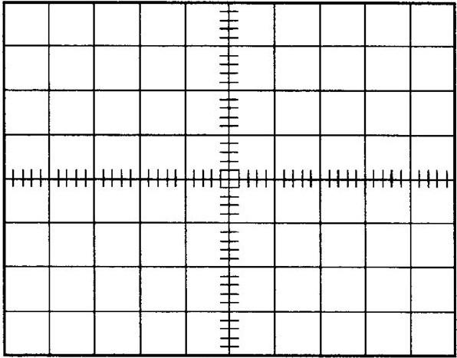
Notice: Do the sketching on the grid below by your hand, photos of DSO screen will NOT be accepted for grading.

Determine the voltage drop across the resistor (from the waveforms you obtained above):
Voltage drop (across the resistor) = _____________

